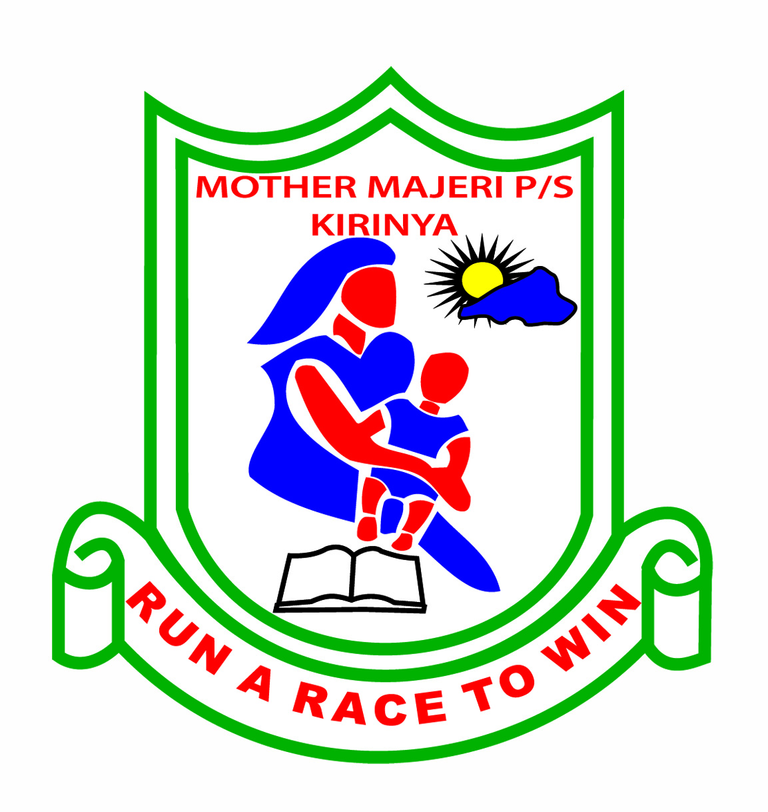MOTHER MAJERI PRIMARY SCHOOL

**END OF TERM II EXAMINATION, 2024**

**A**

**B**

**TOT**

**CLASS : P.2**

# SUBJECT : READING

# DURATION : 2 HOURS & 15 MINUTES

**Name ________________________________________________________**

**Stream______________________**

**1. Sound loudly to the teacher. (1mk)**

ar ay ee pr oo

ph kn wr ch gr

**2. Read these words well (1mk each)**

cross dress chimp may beef

wrong bunch phone arm grass

**3. Sound these words with voiced “th”**

with them than father wither

**4. Read the sentences correctly. (2mks each sentences)**

a) Mummy can eat fried food.

b) Frogs can croak and jump.

c) Elephants are in the jungle.

d) Birds use wings to fly.

e) Kings are in the palace.

**(50 marks)**

**Read the story below to the teacher (1mk each words)**

Zakayo was an old chip. He lived in the zoo. He had a big chest. His chin was long. The branch was his chair. The chicks and the ostriches were his friends. Zakayo did not like chips and chicken. His lunch was a bunch of bananas. He had one child. Zakayo died at 54 years. We miss him so much.